EXPT NO:5 | DEVELOP INTERACTIVE DASHBOARDS FOR DYNAMIC DATA EXPLORATION USING TABLEAU AND POWERBI
DATE: 24.07.2026

PRE-LAB QUESTIONS (PROVIDE BRIEF ANSWERS TO THE FOLLOWING QUESTIONS)

1. What is dynamic data exploration in BI tools, and why is it important?
Dynamic data exploration allows users to interact with data by applying filters, slicers, and drill-down options to analyze information from different perspectives. It helps users identify trends, patterns, and insights quickly. This improves decision-making by enabling real-time and flexible data analysis.

2. What are slicers and filters, and how do they enhance dashboard interactivity?
Slicers and filters allow users to display only the required data based on selected criteria such as date, region, or category. They make dashboards interactive by updating all related visualizations instantly. This helps users focus on specific information without modifying the original dataset.

3. How do Tableau and Power BI support drill-down and drill-through features?
Tableau supports drill-down through hierarchies such as Year → Quarter → Month → Day, allowing users to explore data in greater detail. Power BI provides both drill-down and drill-through features to navigate from summary visuals to detailed reports. These features help users perform deeper analysis efficiently.

4. What is the role of parameters in creating interactive dashboards?
Parameters allow users to change values or switch between different measures and calculations dynamically. They make dashboards more interactive by enabling users to control charts, KPIs, or filters without modifying the underlying data. Parameters provide greater flexibility in data exploration.

5. Name some advanced interactivity features in Tableau and Power BI.
Advanced interactivity features include filters, slicers, parameters, drill-down, drill-through, highlight actions, tooltips, bookmarks, and dynamic dashboards. These features allow users to explore data interactively, compare results, and gain meaningful insights with ease.

IN-LAB EXERCISE:
OBJECTIVE:
To design and develop interactive dashboards in Tableau and Power BI for dynamic data exploration, enabling users to analyze, filter, and drill down into data for deeper insights.

PROCEDURE:
- Data Collection:
  - Import datasets from sources such as Excel, CSV, SQL Server, or online APIs.
  - Dataset: Retail Sales Dataset with fields such as Order Date, Region, Product Category, Sales, Profit, Quantity.
- Data Preparation and Transformation:
  - Ensure proper date formats for time-based analysis.
  - Handle missing or incorrect values.
  - Create calculated fields (e.g., Profit Margin %, Sales Growth %, Year-to-Date Sales).
- Data Aggregation and Hierarchies:
  - Create hierarchies (e.g., Year → Quarter → Month → Day).
  - Aggregate data by region, product category, or customer segment.
- Designing Interactive Elements:
  - Filters & Slicers: Allow filtering by product category, date range, or region.
  - Parameters: Let users switch between KPIs (e.g., Sales vs. Profit).
  - Drill-down: Enable users to explore data from summary to detail.
  - Tooltips: Add contextual details when hovering over data points.
- Dashboard Development:
  - Tableau: Use interactive filters, parameter controls, and highlight actions.
  - Power BI: Use slicers, bookmarks, and drill-through pages.
  - Add KPI cards for key metrics like Total Sales, Total Profit, Top Selling Product.
  - Use maps for regional sales analysis, line charts for trends, and bar charts for category comparisons.
- Testing Interactivity:
  - Ensure slicers and filters update all relevant visuals dynamically.
  - Test drill-down and drill-through functionality for accuracy.
- Publishing and Sharing:

  - Tableau: Publish on Tableau Public or Tableau Server.
  - Power BI: Publish to Power BI Service and share via workspace access or public link.
Experiment Dataset:
Retail Sales Dataset
Fields Used:
- Order Date – Date of the order
- Region – Sales region
- Product Category – Category of product sold
- Sales – Sales revenue
- Profit – Net profit from the order
- Quantity – Units sold

TABLEAU:

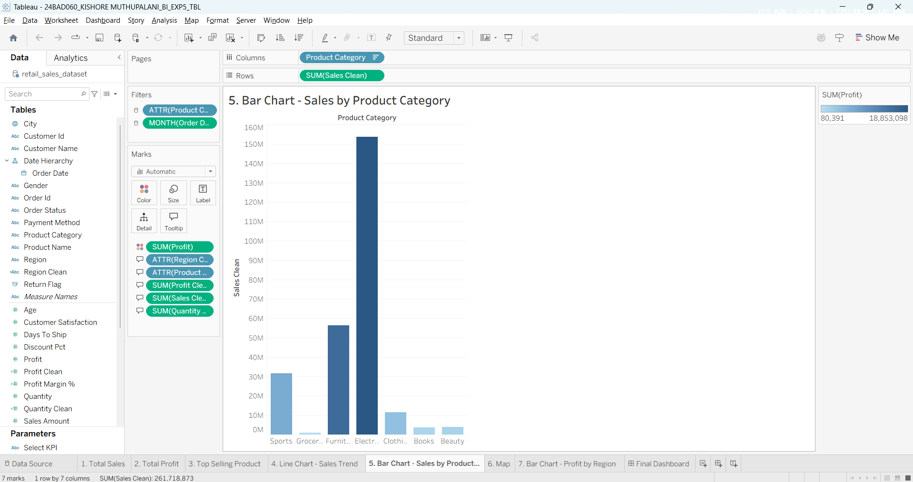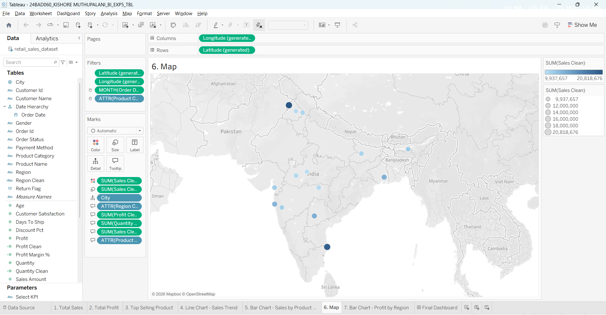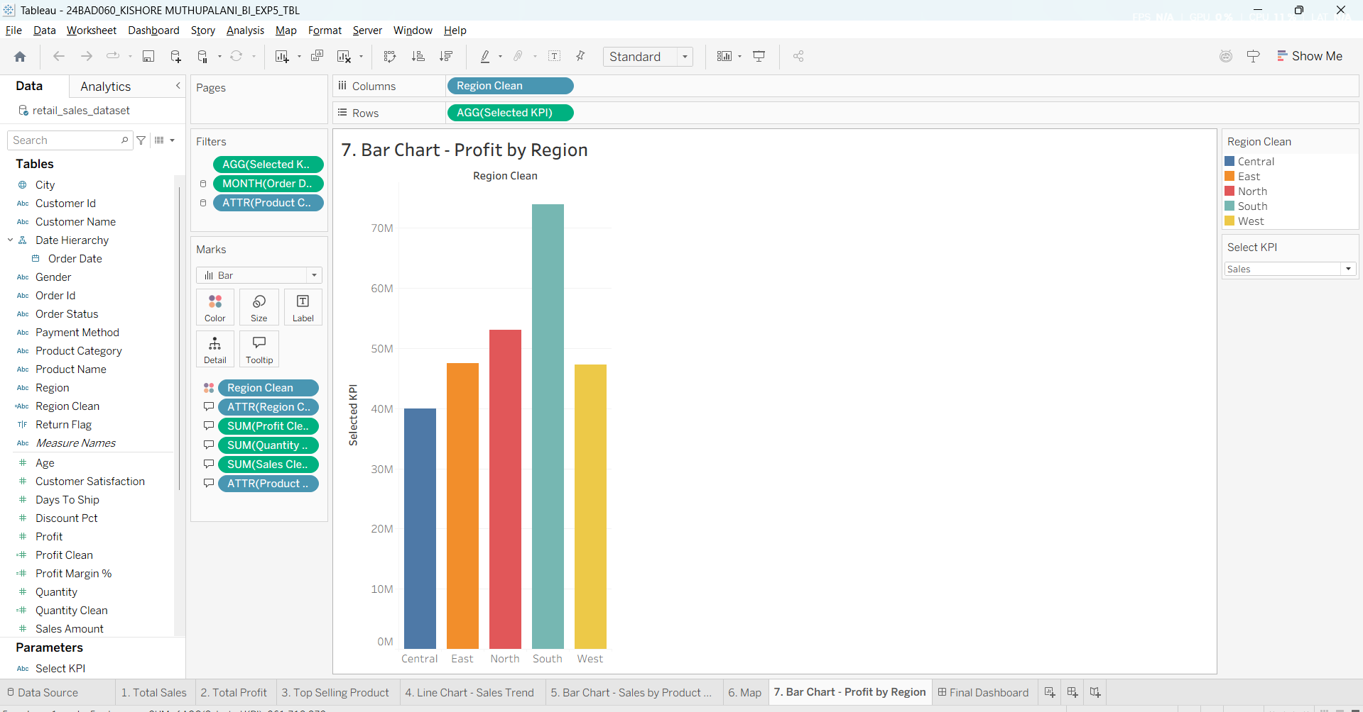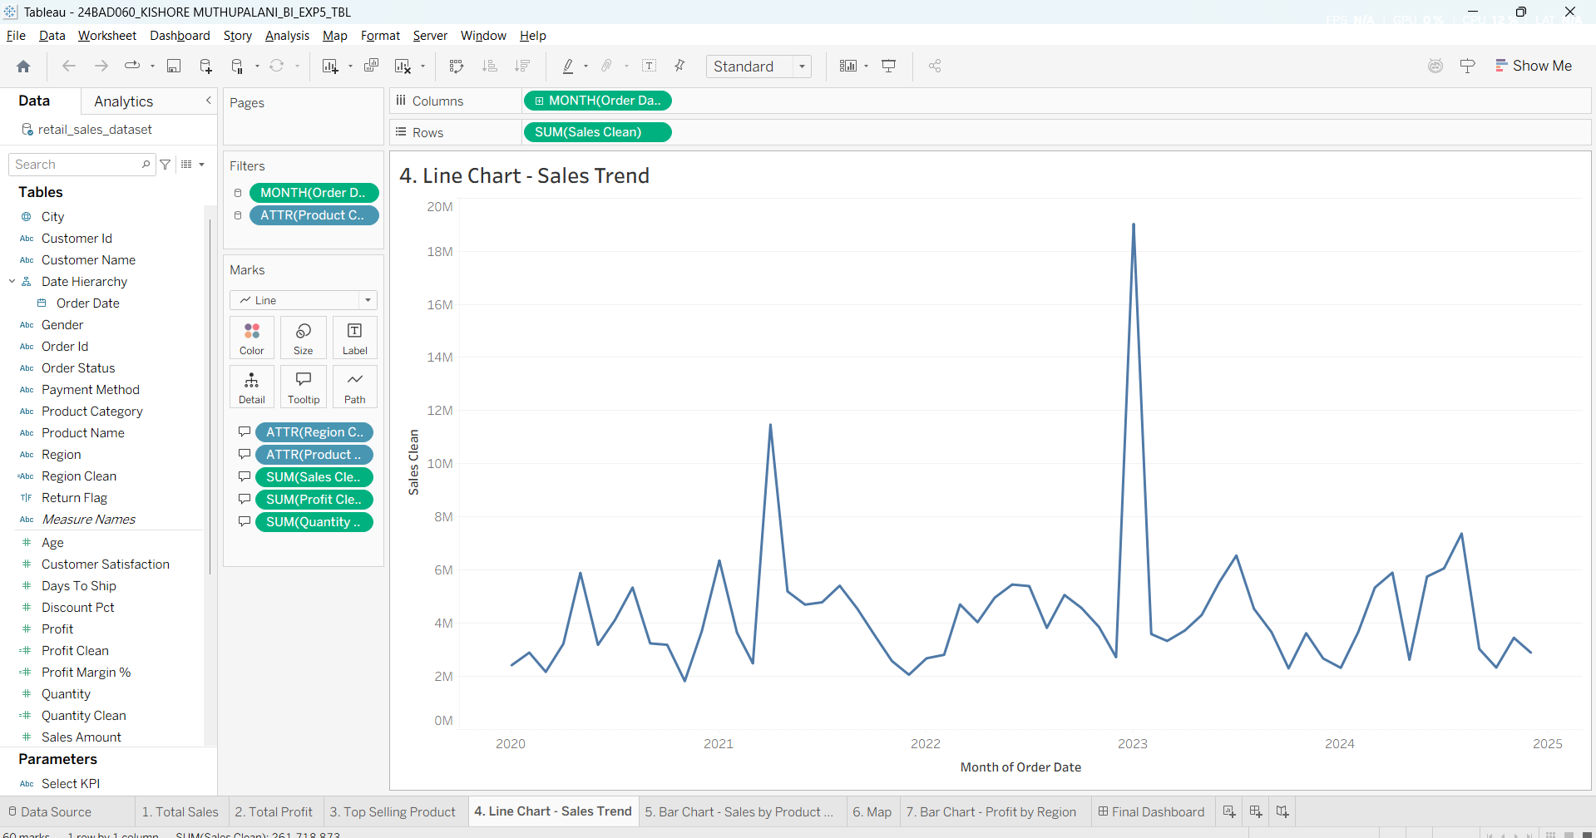
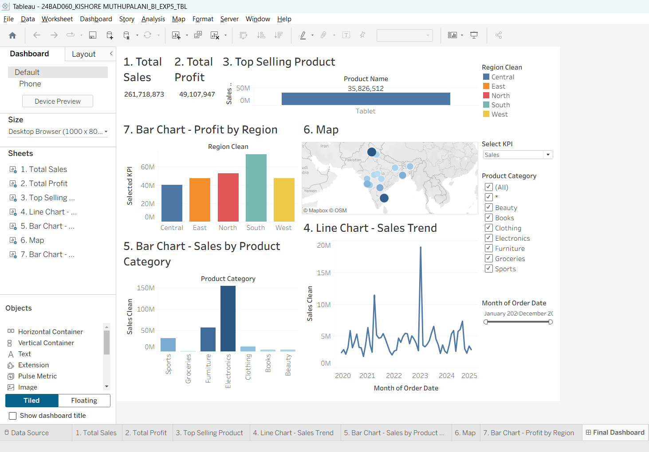

POWER BI:
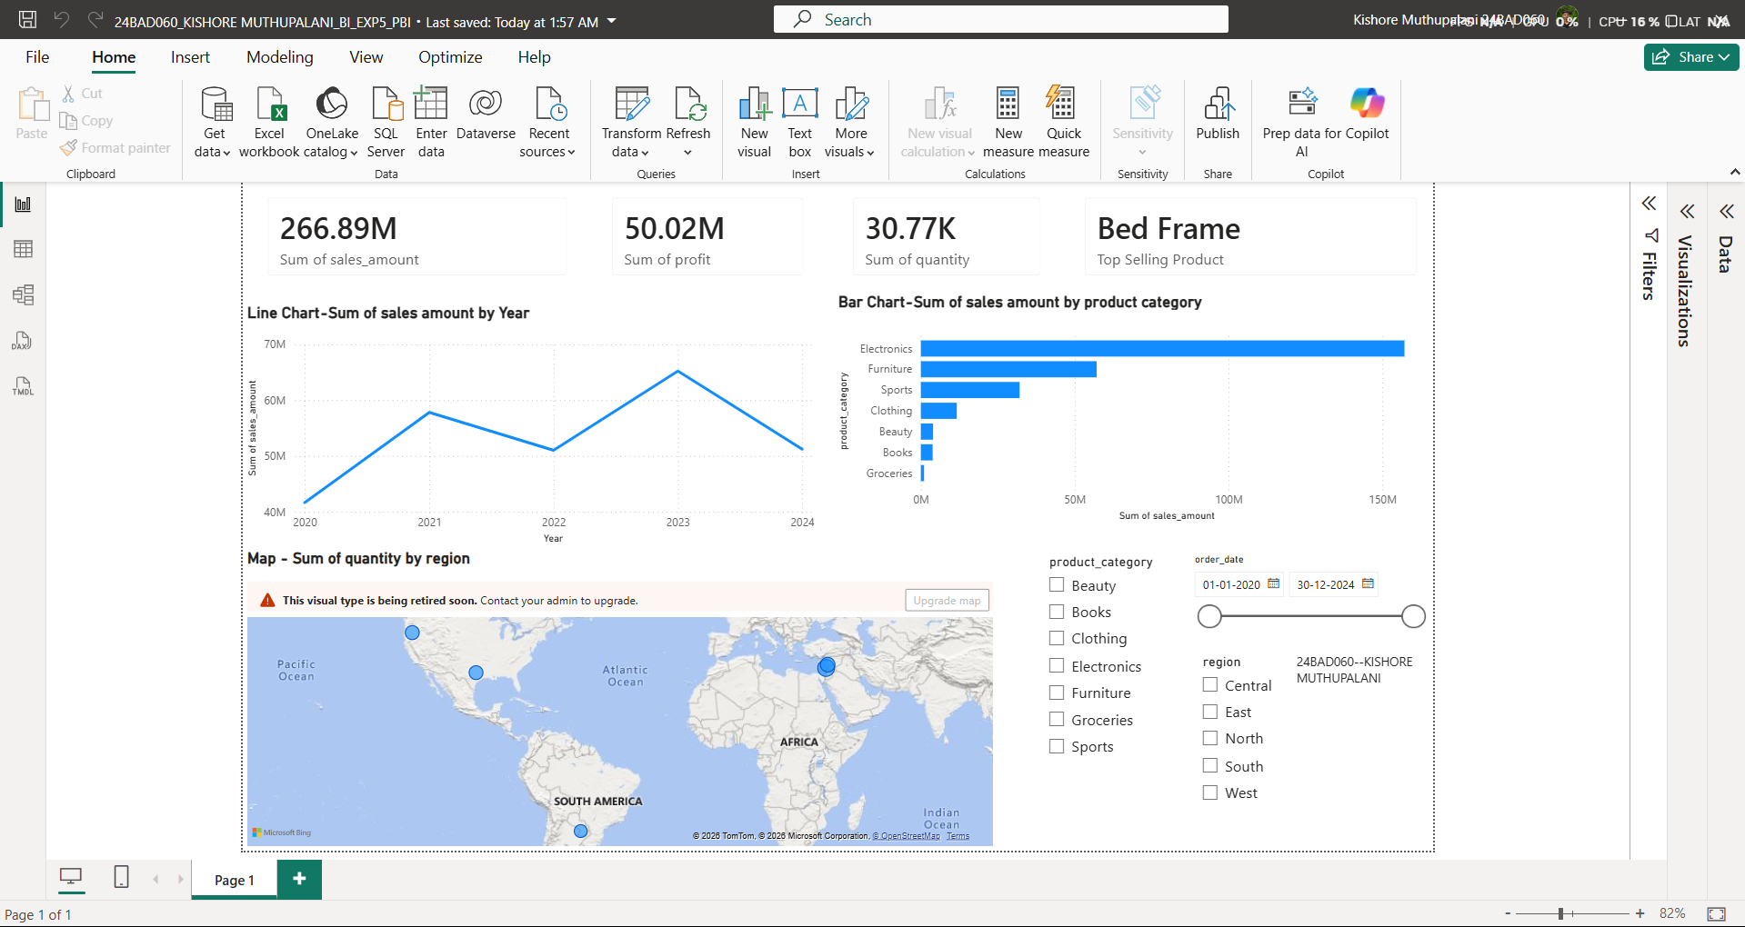

POST-LAB QUESTIONS (PROVIDE BRIEF ANSWERS TO THE FOLLOWING QUESTIONS)

1. How did interactivity improve the analysis experience in your dashboard?
Interactivity made the dashboard more flexible by allowing users to filter data using Region, Product Category, and Order Date without modifying the dataset. For example, the dashboard dynamically updated KPI cards such as Total Sales (261,718,873) and Total Profit (49,107,947) along with the line chart, map, and bar charts. This enabled quick comparison of sales trends and regional performance in a single dashboard.

2. Which interactive feature (filters, drill-down, parameters, etc.) was most useful and why?
The Select KPI parameter in Tableau was the most useful feature because it allowed the Profit by Region chart to switch dynamically between different measures such as Sales and Profit without creating separate worksheets. Combined with the Product Category and Order Date filters, it made the dashboard more interactive and reduced the need for multiple visualizations while improving data exploration.

3. What challenges did you face while implementing drill-down or dynamic filters?
The main challenge was ensuring that filters updated all dashboard components consistently. Initially, some filters affected only individual worksheets instead of the complete dashboard. This was resolved by applying filters to all worksheets using the same data source and verifying that the parameter-controlled chart, KPI cards, line chart, map, and category chart responded correctly to every selection.

4. How do tooltips contribute to better dashboard storytelling?
Tooltips provided additional context without overcrowding the dashboard. In the map and bar charts, hovering over a mark displayed important details such as Region, Product Category, Sales, Profit, and Quantity. This allowed users to explore detailed information while keeping the dashboard clean and making comparisons easier during analysis.

5. What additional features would you add to make the dashboard more insightful?
To improve the dashboard further, I would add Year → Quarter → Month drill-down, forecasting for future sales, and Top/Bottom 10 product analysis. I would also include profit margin trend charts, conditional colour indicators for high and low-performing regions, and dynamic KPI comparisons. These enhancements would provide deeper insights beyond the current metrics, including Total Sales (261.7M), Total Profit (49.1M), and the Top Selling Product (Tablet – 35,826,512) shown in the Tableau dashboard.

RESULT:
The retail sales dataset was successfully transformed, aggregated, and visualized into interactive dashboards in Tableau and Power BI. Filters, slicers, drill-downs, and parameters enabled dynamic exploration of sales and profit trends by region, product category, and time period. The resulting dashboards allowed for quick insights and deeper analysis, enhancing decision-making capabilities.

ASSESSMENT

Description | Max Marks | Marks Awarded
Pre Lab Exercise | 5
In Lab Exercise | 10
Post Lab Exercise | 5
Viva | 10
Total | 30
Faculty Signature

